 | YEAR 12 MATHEMATICS SPECIALIST  SEMESTER ONE 2017  QUESTIONS OF REVIEW 2: Functions

Name: _______________________

Wednesday 29th March Time: 40 minutes Mark /35

Calculator free.

- [3 & 3 = 6 marks]

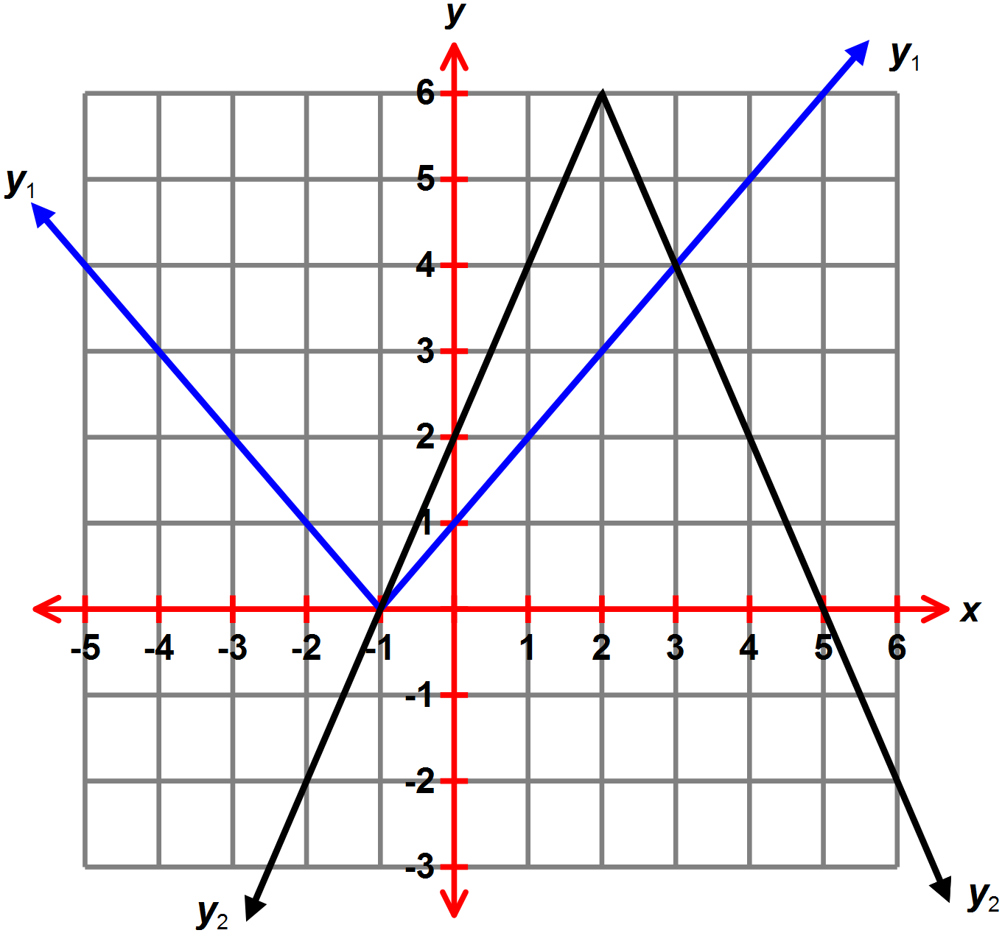The graphs of y₁ and y₂ are shown on axes to the right.

- Use the graph to solve the following equations.

- State the equation for the graph of

- y₁ (ii) y₂

- [5 marks]

Calculate where intersects .
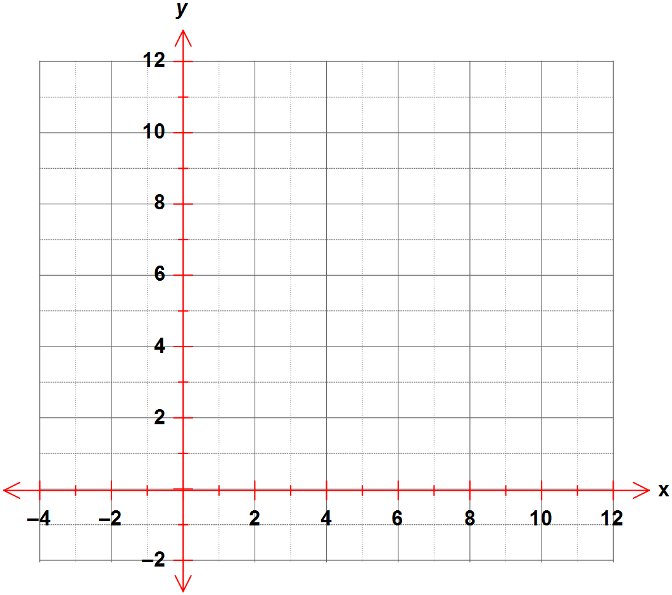Represent your solution on the axes provided.

- [5 marks]

and

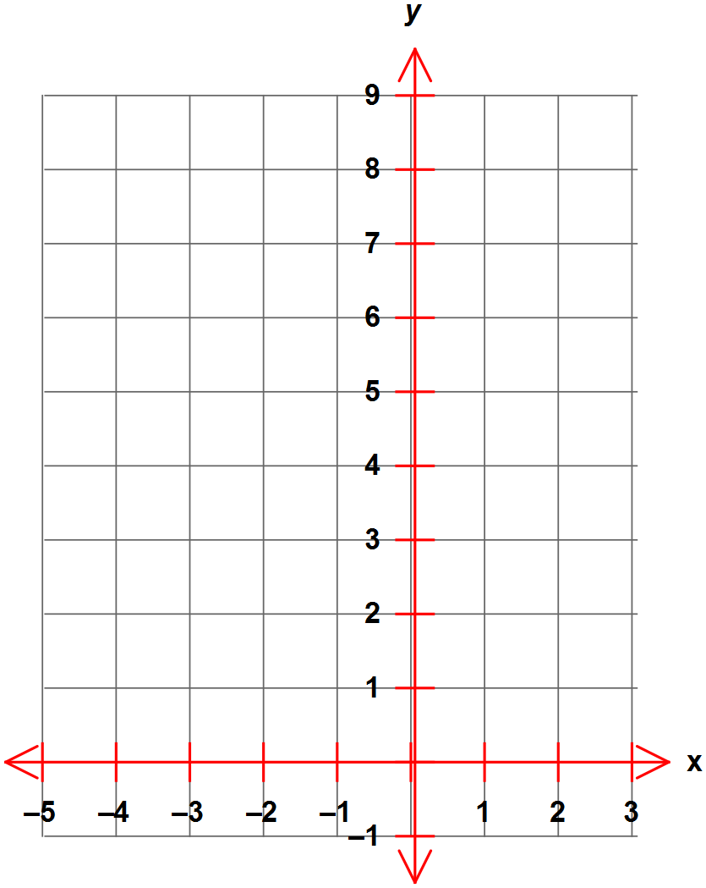Determine a piecewise defined expression for the sum and sketch on these axes.

- [2, 2 & 6 = 10 marks]

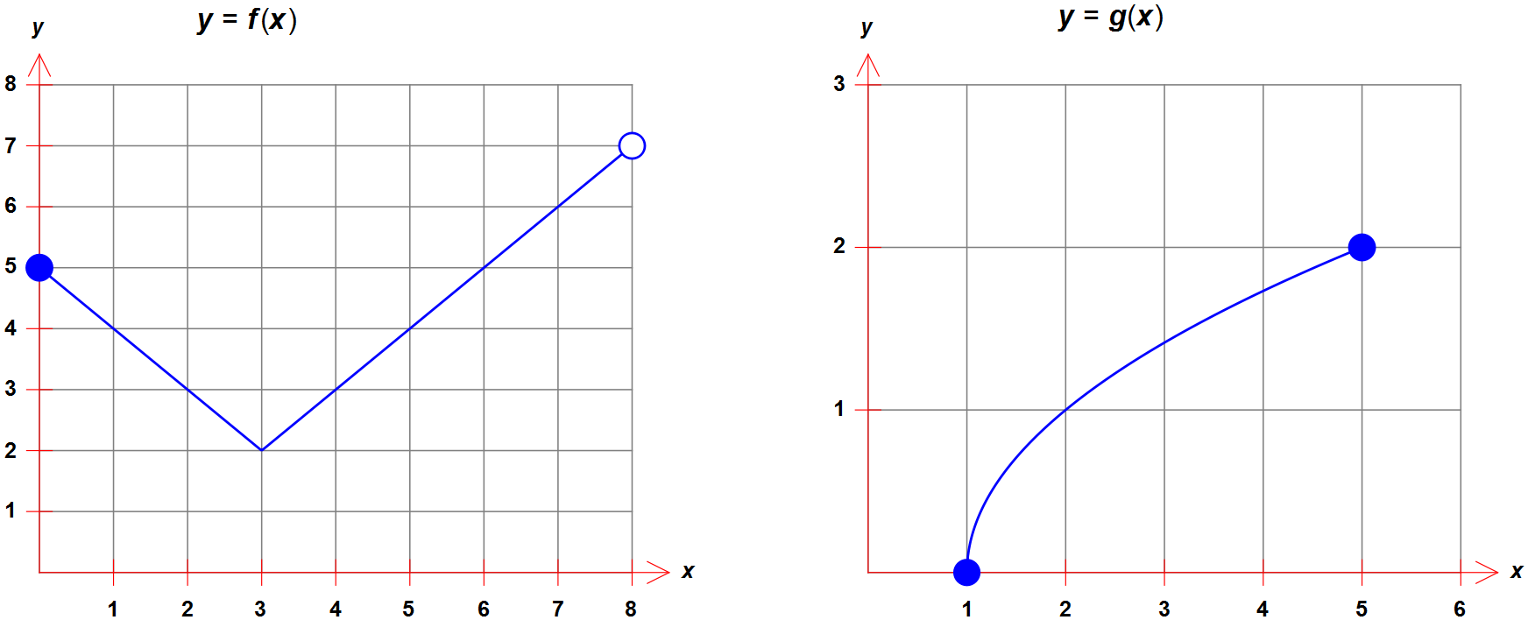The graphs of and are shown.

  - Does possess an inverse function? Explain

  - Find

(i) (ii)

  - State

(i) the domain of g (ii) the range of f

(iii) the maximal range of

(iv) the maximal domain of

- [2, 2, 2, 1 & 2 = 9 marks]

The axes to the right show the graph of .
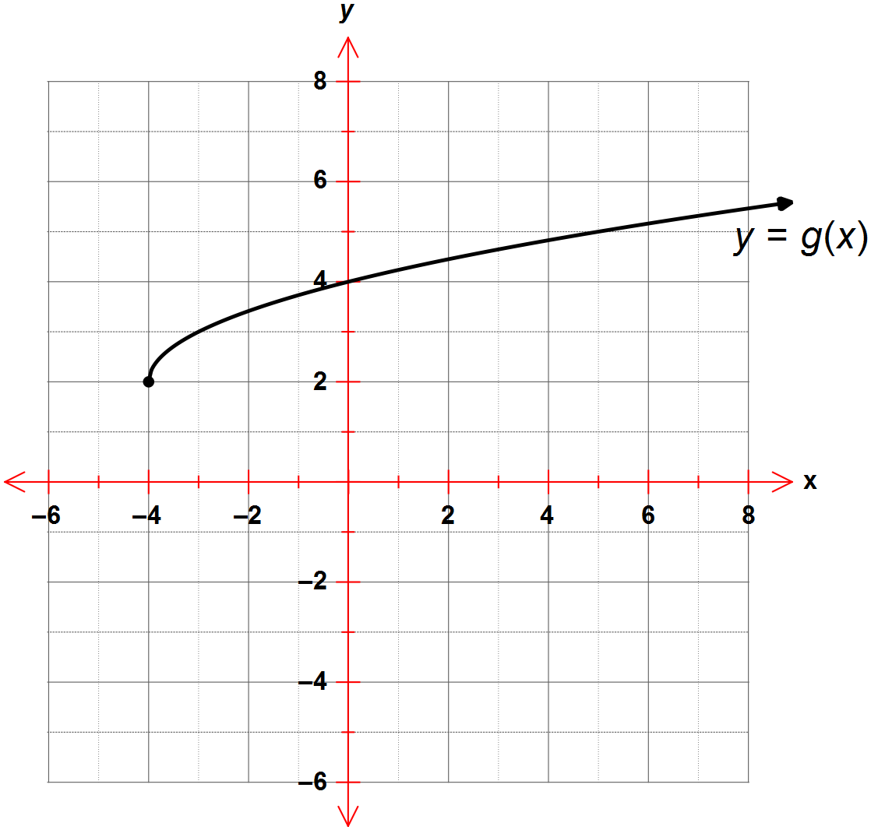
- Find the value of if .

- (i) State the range of

(ii) State the domain of

- Find the defining rule for in simplest form.

- Is one-to-one?

- On the axes above, add a sketch of the graph of showing the coordinates of all relevant features clearly.

